Global Gateway Certifications Sdn Bhd intent that certified organizations should be able to benefit from identifying visually their status through the use of the marks (symbols or logos) which Global Gateway Certifications Sdn Bhd owns. However, the organizations displaying them should not mislead anyone, devalue or degrade the mark, use them illegally or be contrary to various recognized standards or guides.
To ensure that the correct markings are used, the following rules shall be observed by all Global Gateway Certifications Sdn Bhd certified organization,
- The marks may only be used on correspondence, advertising, promotional material and must not be used except in connection with those goods or services described in the scope statement of the certification certificate.
- The marks may be used only on those materials or in communication media (brochure, internet, letterhead, marketing literature, advertising, invoice stock forms etc.) relating to the particular facility and processes/product lines included within the scope of certification.
- The marks shall not be used in such a manner that would bring the certification into disrepute and lose of public trust.
- The marks shall not, under any circumstances, be used directly on or closely associated with products in such a way as to imply that Global Gateway Certifications Sdn Bhd certifies the products themselves unless the products have been manufactured and certified under an accredited product conformity scheme.
- The marks shall not be used in such a manner that would bring the certification into disrepute and lose of public trust.
- The use of certification marks on laboratory test reports, calibration records, inspection reports or certificates is explicitly forbidden.
- The certified organization is restricted from using the Global Gateway Certifications Sdn Bhd certificate or components from the certificate to generate its own version/representation of a certificate of conformance. Such action would constitute a misuse of the Marks.
- The marks may be used by the certified organization and must always be used in conjunction with the applicable standard.
- The certified organization undertakes to discontinue any use of the marks that might be misleading and are unacceptable to Global Gateway Certifications Sdn Bhd.
- Upon suspension, withdrawal or termination of certification for whatever reason, the certified organization undertakes to immediately discontinue the marks from all advertising matter, stationery, material on which they appear that contains a reference to certification.
- Upon the scope of certification is reduced, the marks from all advertising matter, stationery, material on which they appear that contains a reference to certification shall be amended accordingly.
- The accreditation mark shall always be used in conjunction with the Global Gateway Certifications Sdn Bhd marks. Under no circumstances can a certified organization use the Accreditation Mark in isolation of the Certification mark to which it relates. All Accreditor marks should be used following the rules set in the of accreditation requirements. Holders of certified organizations may use Global Gateway Certifications Sdn Bhd marks without accreditation mark if they wish.
- Accreditation marks shall not be used in any way that might mislead the reader about the status of a certified organisation, activities outside the scope and imply that product, process or service is certified.
- Accreditation marks shall not be used in such a way as to suggest that Global Gateway Certifications Sdn Bhd or Accreditation Bodies has certified, or approved, any product or any service supplied by a licensee of a mark, or in any other misleading manner.
- Accreditation marks shall not be used in such a way as to imply that Accreditation Bodies accepts responsibility for activities carried out under the scope of accreditation and/or certification.
- Accreditation bodies which Global Gateway Certifications Sdn Bhd accredited for reserves the right to impose other requirements with regards to the use of the accreditation marks. Such requirements shall be formally documented.
- Electronic reproduction of the marks is permitted provided that the conditions set in these given rules are met and,
  - the marks are reproduced so that infilling does not occur.
  - degradation and/or distortion of the mark’s graphic are avoided.
  - the marks shall be prepared from mark masters and redrawn approximations are avoided.
- In exceptional circumstances, which are usually dictated by reason of space limitation or cost, the marks may be reproduced at a reduced height, provided that irrespective of the height of reproduction, the mark must be legible, with no infilling.
- Certification marks and accreditation marks where practicable shall be reproduced or displayed in the appropriate form and size as in figure below. Any enlargement or reductions shall retain the same proportions as in the marks master but shall be sufficient large for the wording to be clearly distinguishable. When used on paper, it may also be embossed or stamped.
- Generic instruction,
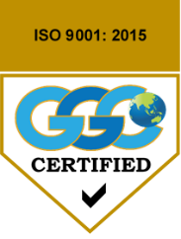 | State standard certified up to 3 lines
- Samples,
 |  | 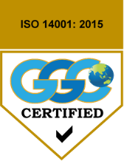 |  | 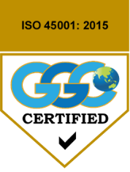 |  | 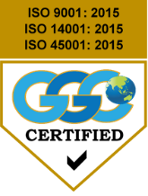
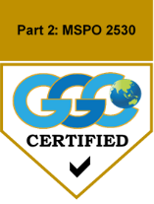 |  | 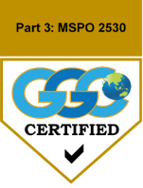 |  | 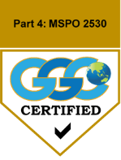 |  | 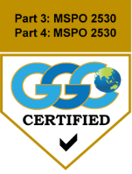
- When used with accreditation mark,
Accreditation Mark

- For scheme owner requirements on Logo Usage (Malaysian Sustainable Palm Oil (MSPO) Logo usage), further reference and guidelines shall be referred to MSPO Certification Scheme Documents or at website https://mspo.org.my/mspo-blogs/the-usage-of-the-mspo-logo

